**Ideation Phase**

**Empathize & Discover**

|  |  |
| --- | --- |
| Date | 19 September 2022 |
| Team ID | PNT2022TMID43271 |
| Project Name | Project - xxx |
| Maximum Marks | 4 Marks |

**Introduction**

Approaching design thinking from a systematic methodology means that emphasis is more on information than feelings. Of Course in a creative’s mind, empathizing is more about experiencing the problem.

Through experience a creative person is able to conceptualize the problem. So that their creative minds can develop ideas and intuition. This, in particular, is a mindful task that creative are able to do almost naturally.

But we are going to talk about the Empathize stage from an organization’s perspective. Empathize might sound simple but it’s all about understanding the needs, wants, pain points of the user of your design.

These are critical for the design of the products and services. In particular, pain points are trickier but crucial for the design of functioning products. Hence here empathize becomes more about relevant research and data collection.

Research can be divided into primary and secondary research. To elaborate, secondary data is already developed data from third party sources. But it’s useful since it is relevant to your research. So greater the relevance the more useful the data.

Primary research is first hand research that you may conduct to develop insights about your users. So the usefulness of your primary research depends entirely on your research methodology.

**Techniques for empathizing**

Firstly it is important to remove all biases, assumptions that you may have. Particularly because they tend to create misconceptions in the empathy stage. And it domino affects its way to the ideation phase.

This is particularly dangerous as it may result in flaws in the design. These biases may be subtle so the designer must be very careful with their presuppositions. One way of doing that is by focusing on the core techniques for empathizing.

The core objective of this stage is to observe, engage and immerse into the environment. So in a systematic design thinking process it can be achieved through various techniques. Each with their own applications.

Starting with interviews, that are conducted with users, field experts and other producers. Interviews may serve as organic knowledge to build understanding of the problem. They involve feelings and opinions which may be useful for the design.

On the other hand, surveys serve as good insights to highlighting the needs and wants of the users. They are easier to generate and very accessible to all. You may use software’s to process information from surveys.

Shadowing is another method for developing useful understanding of your consumer. In particular, when the design is a service for user consumption. So it is important to understand consumer behavior and shadowing serves that purpose.

Documentaries are another source of information that you must not ignore. Great documentaries could serve as a direct source of understanding for needs and wants. However documentaries create bias since you are viewing the environment from a narrow lens.

Journals and body language can develop quite an intrinsic understanding of your consumers. This understanding integrated with design would produce niche products and services that are unique and detailed.

**Empathy Map**

As a product team you may have a dozen design projects to make. Each with their own individual design and ideas. So you may want to test all possibilities and perhaps choose the one that works perfectly for that project.

However in the real world this may not be possible. Considering that you have a limited budget, limited resources and only enough samples of users before they start becoming biased. Here is when an empathy map is useful.

Empathy map is a tool that allows you to understand what the user is thinking, feeling, seeing and saying. So you can visualize and articulate their knowledge. And allows you to understand their needs.

Empathy map starts with open ended interviews with unstructured questions. So that you may develop an unbiased understanding of the user’s perspective. And you must keep your mind open to new information which is the essence of empathy.

The design of the empathy map allows you to create profiles of your users. So that you are able to identify common ground. Or make connections and correlations between commonalities and differences.

\ 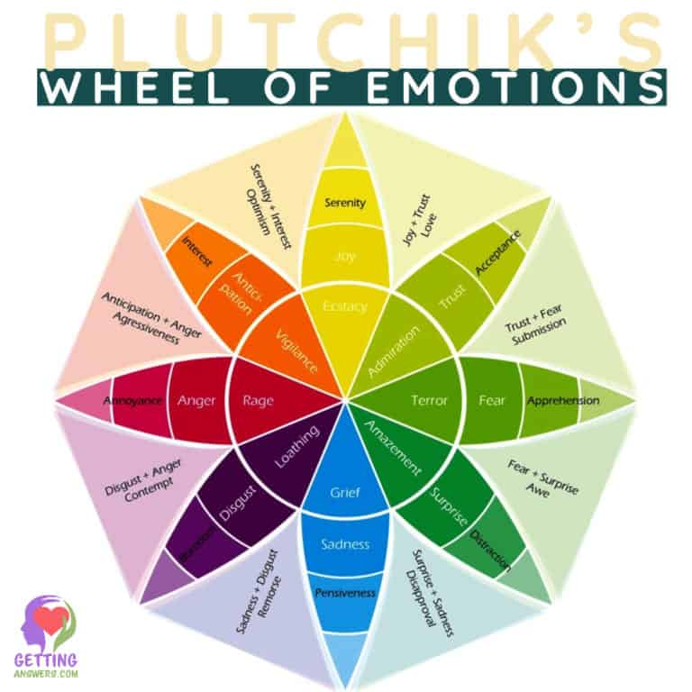

### Define

This is the second stage of the design thinking process. Yet we could also call it hypothesize which would be a more scientific term.

The second stage of the design thinking process is about defining the problem. Or generating a problem statement. More importantly, this stage is about refining the problem into organic form.

Therefore you must give the problem time and space to develop and cook itself. Because often users walk in with a clear idea about the problem. But their ideas develop on exploring the problem on their own as well as with other users.

In the define stage you unpack the information you gathered in the empathy stage. And then you analyze this information to unpack it. And you must look for insights and needs in this analyzed data.

The Define stage is non linear this means that you may find gaps and loopholes. So you might have to go back to the empathy stage and look for more information. Or you might have to continuously gather data as you are refining it.

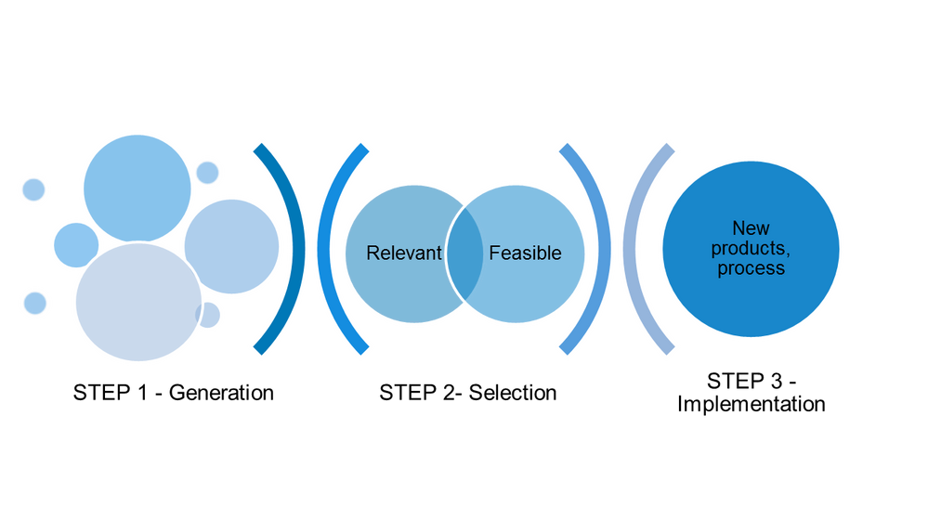

\

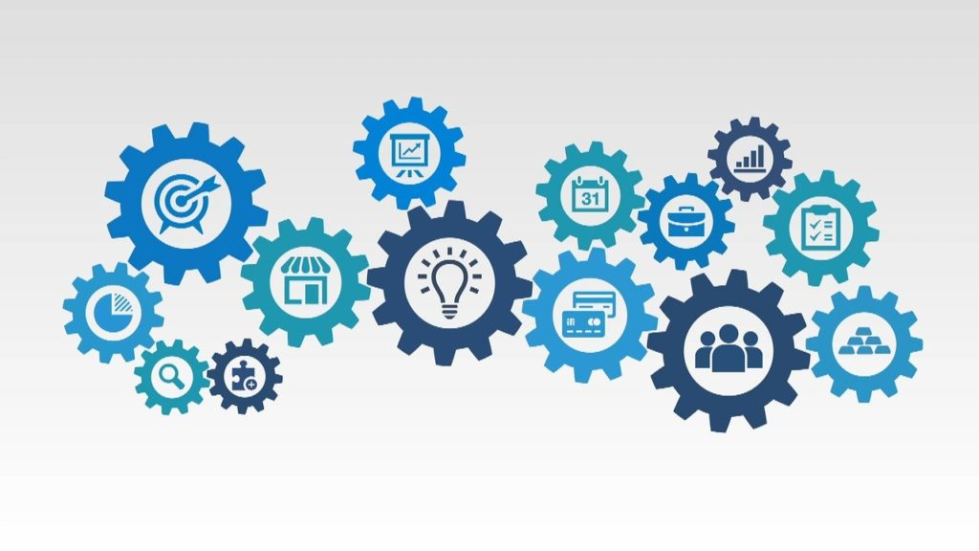

## ****IDEO’s Human - Center Design Mindsets****.

Thinking like a designer can transform the way organizations develop products, services, processes, and strategy. This approach, which IDEO calls design thinking, brings together what is desirable from a human point of view with what is technologically feasible and economically viable. It also allows people who aren’t trained as designers to use creative tools to address a vast range of challenges.

* **Inspiration**is means of opening up the problem or opportunity space through research activities.
* **Ideation**is the process of generating, developing, and testing ideas.
* **Implementation**is the path that leads from the project stage into people’s lives.

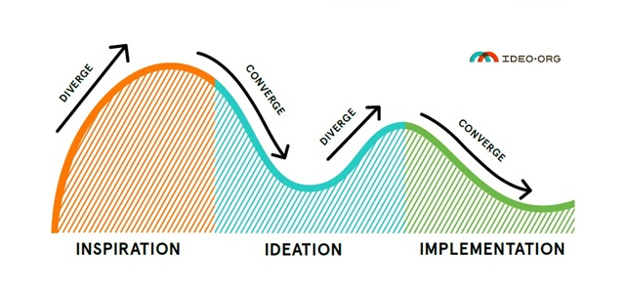The 3 core activities of Design Thinking

## Ideation

In the  phase, a diverse group of multidisciplinary people get involved to create experiences and test contending ideas against the insights which have been drawn from the inspiration phase.

After spending time in the field observing and doing design research, a team goes through a process of synthesis in which they distill what they saw and heard into insights that can lead to solutions or opportunities for change.

**conclusion**

In the **inspiration**phase, designers distill their ideas into insights from on-field observations and design research conducted on human behaviors which would lead to tangible solutions.

First of all is a good starting point for designers to go out into the world and observe the actual experiences of people. How they improvise their way through their daily lives.